Read me file – LMS

1. Android Studio can be downloaded from the official website at <https://developer.android.com/studio>.

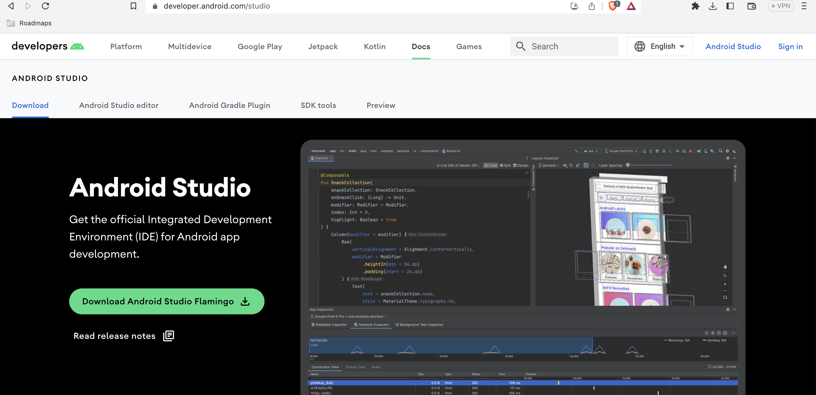

1. Open the.dmg file that you downloaded.
2. Place the Android Studio icon in the "Applications" folder.
3. From the "Applications" folder, launch Android Studio.
4. When asked, allow Android Studio access to the system.
5. Select "Custom" as the installation type and the components you want to install (for example, Android SDK, Android Virtual Device).
6. To finish the installation, follow the on-screen directions.

Before installing Android studio, make sure that Java and JDK is installed in the MAC.

Running LMS application:

Launch Android Studio and navigate to your Android application project.

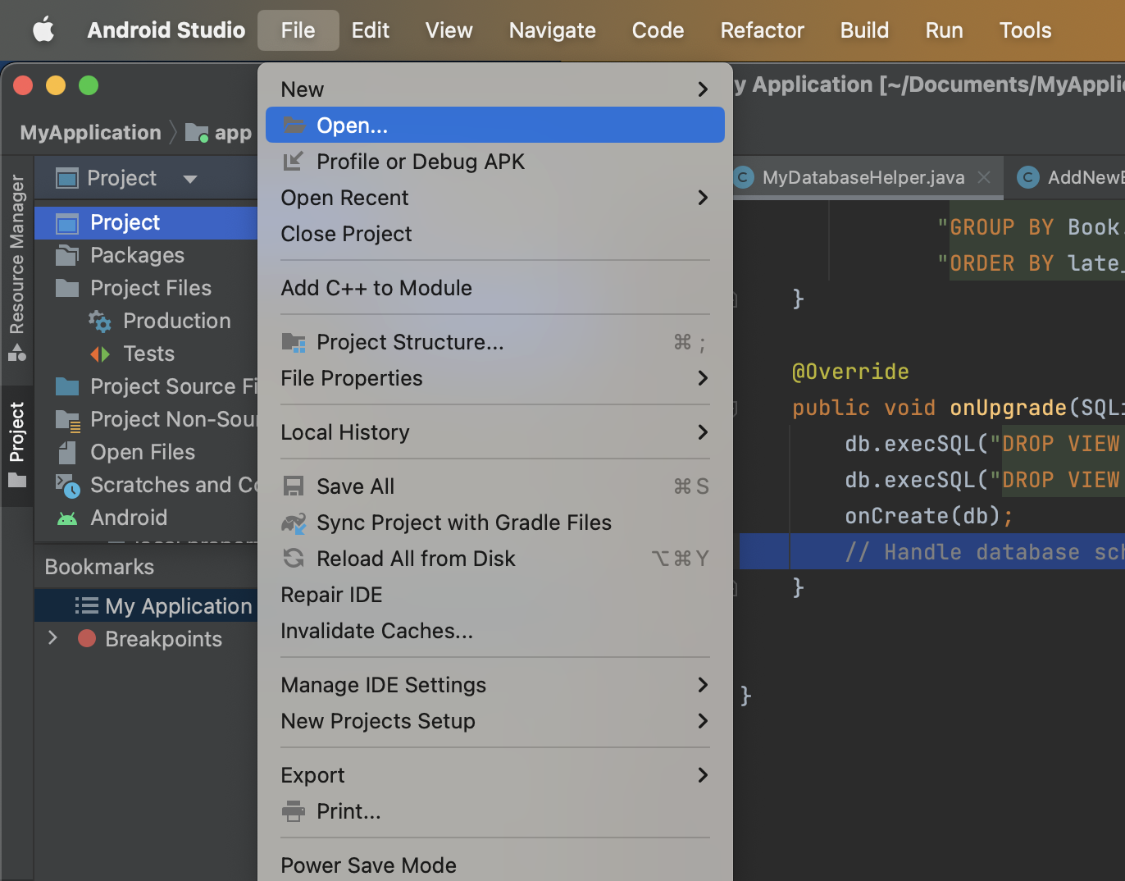

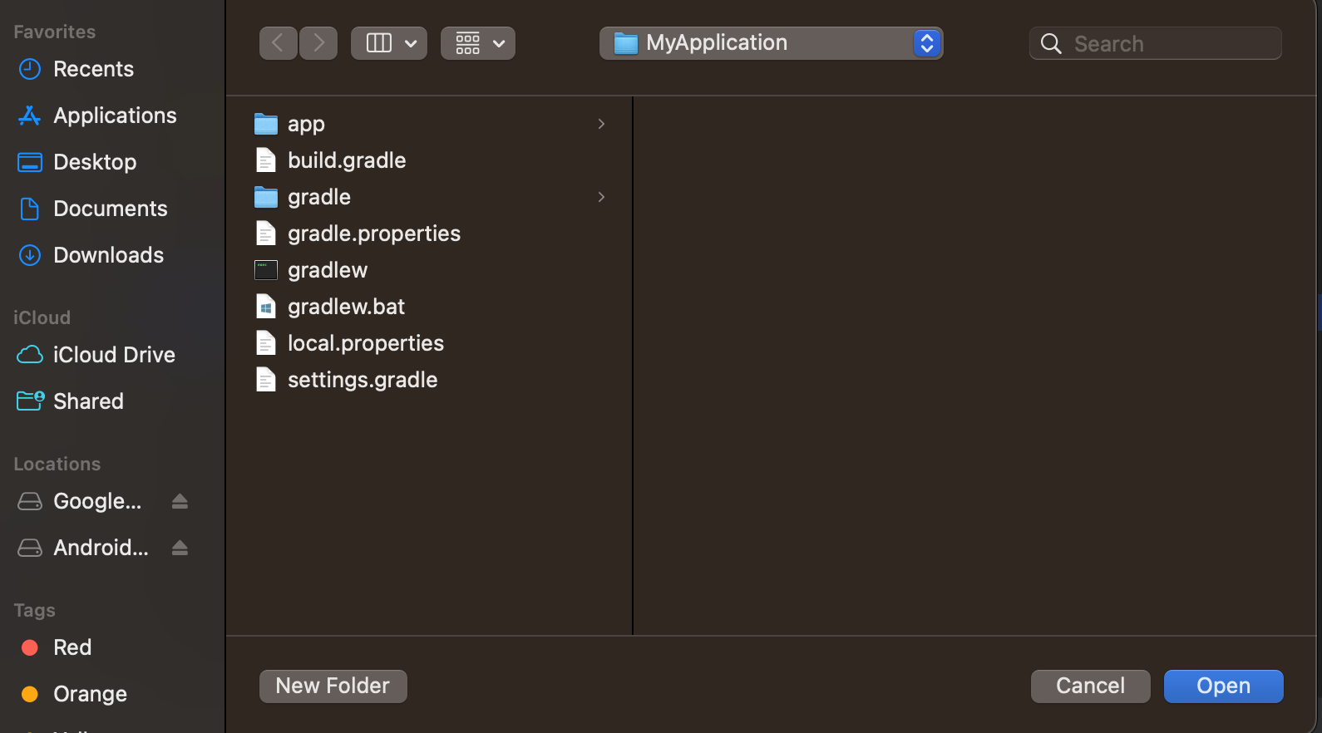

Check that the project was successfully constructed by selecting "Make Project" from the "Build" menu.

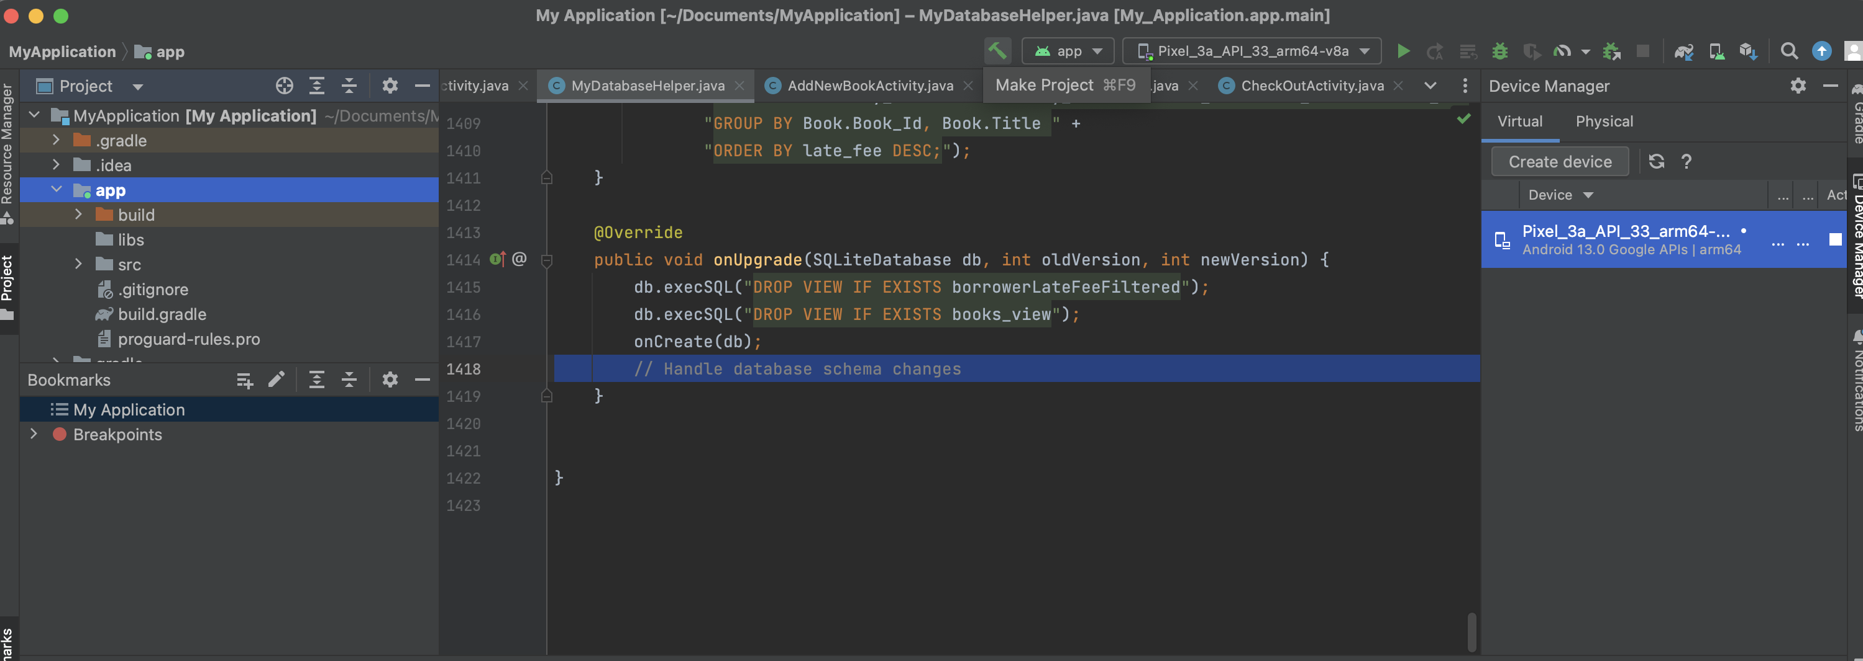

Click the "AVD Manager" icon in the toolbar, or go to the "Run" menu and then pick "AVD Manager."

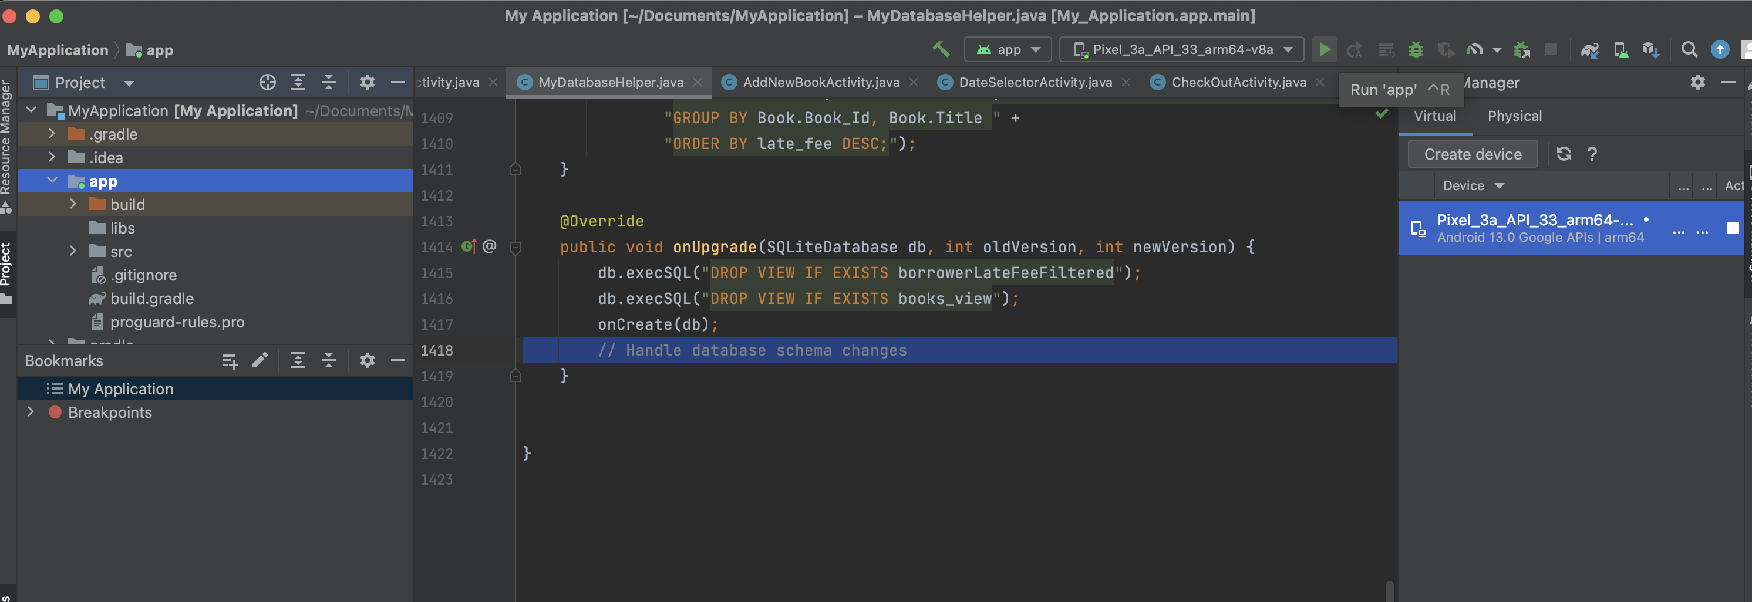

Click the "Create Virtual Device" button in the AVD Manager.

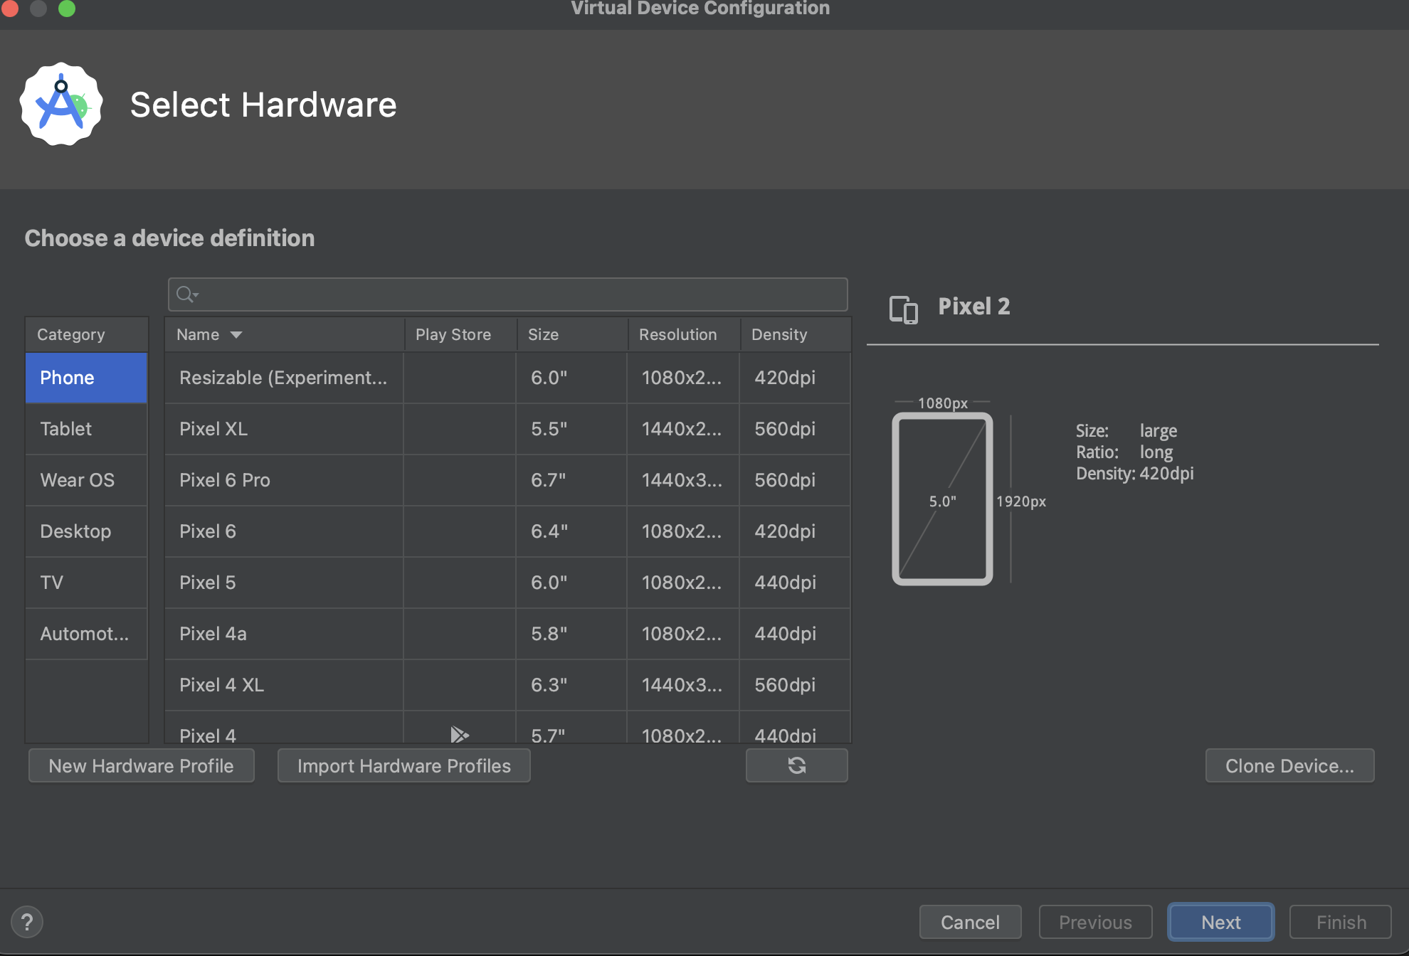

Click "Next" after selecting the device specification for the emulator you wish to use.

Click "Next" after selecting the system image for the emulator.

Configure the emulator parameters, such as the name, storage, and other choices, and then click "Finish."

